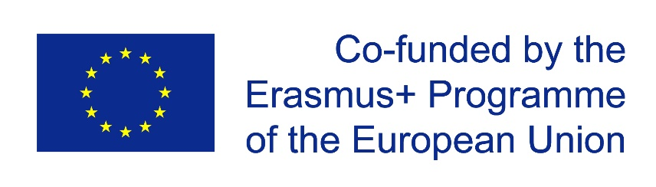**http://aknt.knu.edu.ua/wp-content/uploads/cybphys_logo_smal-300x54.jpg**

**CybPhys: Development of practically-oriented student-centred education in the field of modelling of**

**Cyber-Physical Systems**

PROJECT NUMBER: 609557-EPP-1-2019-1-LV-EPPKA2-СBHE-JP

**Deliverable D 6**

**Dissemination and Exploitation Plan**

*revised from 01/06/2021*

**Document Properties**

|  |  |
| --- | --- |
| **Deliverable No.** | 6 |
|  |  |
| **Deliverable Title** | Dissemination and Exploitation Plan |
|  |  |
| **Lead beneficiary** |  |
|  |  |
| **Due date of deliverable** |  |
|  |  |
| **Actual submission date** |  |
|  |  |
| **Dissemination level** | PU |
|  |  |

**Dissemination Level**

PU = Public

PP = Restricted to other programme participants (including the Commission Services)

RE = Restricted to a group specified by the consortium (including the Commission Services)

CO = Confidential, only for member of the consortium (including the Commission Services)

**Document History**

|  |  |  |  |
| --- | --- | --- | --- |
| **Version** | **Date** | **Issued by** | **Description** |
|  |  |  |  |
| 1 | 01-02-2020 | Belarusian State University [BSU] | First issue |
|  |  |  |  |
| 2 | 01-06-2021 | Kryvyi Rih National University [KNU] | The updated version related to Covid-19 impact |
|  |  |  |  |
|  |  |  |  |
|  |  |  |  |

**Executive Summary**

A well designed and implemented dissemination and exploitation plan is imperative to ensure that the project initiatives and outcomes are promoted and generate the required impact. Both the short-term and long-term outcomes of the project such as the educational initiatives undertaken and the newly generated knowledge, the social and pedagogical implications, , strengthening the academia – industry network are important for delivering high quality education, new training programs for the targeted stakeholders, the development of ICT-based teaching, and preparing Ukrainian students to compete in the declared field. Consequently, the dissemination and exploitation activities need to be further highlighted in a project Dissemination and Exploitation plan.

This document, which is entitled “Dissemination and Exploitation Plan”, is designed to report the current and planned dissemination and exploitation activities within CybPhys Project. This document has been structured to provide a general description of the dissemination and exploitation plan, a description of the project’s anticipated outcomes, a list of the participating organizations, and other related dissemination and exploitations tools that will be utilized to raise awareness about the project and its broader pedagogical and social impact for Ukrainian students, academic stuff and the participating academic and non-academic institutions. The dissemination and exploitation plan also offers a synoptic view on the actions already undertaken and future actions that will be undertaken to complete the project implementation and to promote further the project and its outcomes.

**Contents**

|  |  |  |
| --- | --- | --- |
|  | Introduction | 4 |
| 1 | Objectives of the dissemination and exploitation plan | 5 |
| 2 | Methodology of the dissemination and exploitation in plan | 5 |
| 3 | Overview of Aims and Objectives of CybPhys Project | 7 |
| 4 | Description of Dissemination and Exploitation Plan | 8 |
| 4.1 | Building awarenes | 9 |
| 4.1.1 | Internet Presence | 9 |
| 4.1.2 | Promotional materials | 12 |
| 4.2 | Building understanding | 12 |
| 4.2.1 | Announcements/Presentations at workshops, seminars and conferences | 14 |
| 4.2.2 | Press releases | 14 |
| 4.2.3 | Communication to other projects | 15 |
| 4.2.4 | Final conference | 15 |
| 4.2.5 | Publications | 15 |
| 5 | Achieving Engagement | 15 |
| 5.1 | Maximizing of impact and sustainability | 15 |
| 6 | Description of Partner Involvement in the Dissemination and Exploitation Activities | 16 |
| 7 | Conclusion | 18 |

**Introduction**

This document presents the Dissemination and Exploitation Plan of the CybPhys project, which is devised when the project starting and will be revised throughout the duration of the project. The document will be used as a point of reference and a guide for the dissemination and exploitation activities undertaken by the consortium partners in order to promote the project goals and tasks, its outcomes, and ensure that quality results were delivered in time. This document is imperative in order to ensure that all actions are realized in a timely manner and the quality of the tasks are met according to the high standards set by the project coordinator and participating partners. This document is guided by the Dissemination and exploitation strategy developed in the G.2 part of the project.

For the current version of the plan, it is also necessary to indicate that the Belarusian partners of the project are Belarusian State University, Gomel State University named after Francisk Skaryna and Mozyr State Pedagogical University withdrew from the project consortium for political reasons. Therefore, information about the dissemination of the project results on the territory of Belarus was excluded from the dissemination and exploitation plan.

The overall objectives of WP6 (Dissemination and Exploitation) are summarized as follows:

* To increase public awareness about CybPhys and its impact
* To motivate students and professionals to follow CybPhys offered courses and education programs
* To ensure sustainability of the project outcomes beyond the project
* The target groups: students, engineers, researchers, academic staff and students from other universities who are not involved in the project, professional associations and the companies that operate in the field of Cyber-Physical Systems (CPS), governmental agencies, national education accreditation agencies
* A Dissemination and exploitation plan was discussed and approved at the Kickoff meeting. The presented plan will be actualized during project running. The progress and impact will be presented by the leader of WP6 at different MC meetings.

According to G.2 issue of the Project application Form, the Dissemination and Exploitation Plan is directed on the following Target Groups:

* **Academic and teaching staff as well as engineers and researchers** of Ukrainian universities involved in the project
* **Bachelor and master students** of participating PCs universities as future employees
* **Employers** (professional associations and the companies that operate in the field of CPS involved into CybPhys project as associated partners)
* **Graduates of the secondary and technical schools** as potential universities’ entrants and their parents
* **HEIs of Ukraine**, which do not directly participate in the project, as potential users of new developed courses, training programs, teaching/learning materials, e-learning system and Sharing Modelling and Simulation environment platform
* **Enterprises of high-tech industries and research institutions** that need specialists with the knowledge in the field of CPS modelling
* **Institutions of the Ministries of Education and Science of Ukraine**, which provide planning of specialists necessary for the industries, research institutions and other HEIs and accept new training programs (curricula).

To supply the approaching of the above-mentioned goals and objectives as well as successful implementation of the project as a whole, in accordance with the the Dissemination and Exploitation Plan the Partners should resolve the following tasks:

6.1. Development of information and promotional materials

6.2. Information sessions for target groups

6.3. Project Web Portal and social media

6.4. Recommendations for new training programs for the targeted stakeholders beyond the project

6.5. Strengthening the academia – industry network

6.6. Hosting and maintenance of e-Learning and SMSE platform beyond the project.

6.7. Strengthening cooperation beyond the project to sustain the outcomes.

The above general objectives as well as methodology of the dissemination and exploitation plan will be discussed in more detail in the following subsections below.

**1. Objectives of the dissemination and exploitation plan**

The dissemination and exploitation activities within the CybPhys project have the following specific objectives:

* Clearly define and ensure the successful realization of the project objectives, outcomes and tangible results, as defined in the project
* Identify and reach the target groups both at the local and national level, such as HEIs, students of different levels in academic faculties, professional associations, the Ministry of Education and Science in Ukraine, as well as other associated partners
* Set up a strategy and propose specific actions to promote awareness about the project and its expected outcomes to organizations at a local, national, and European level
* Set up a strategy and propose actions for building a clear understanding of the pedagogical, institutional, and social implications of the project to Belarus and Ukraine and to the wider European community
* Set up a strategy and propose actions that will aim at engaging Ukrainian and European community in the activities of the project
* Set up a strategy and propose actions that will ensure a high impact, dissemination and exploitation, and sustainability of the project and its expected outcomes.

**2 Methodology of the dissemination and exploitation plan**

The dissemination and exploitation plan is coordinated by Kryvyi Rih National University, but all consortium partners and other associated partners are invited to contribute actively to the realization of all activities described in Dissemination and Exploitation Plan of the project. Multiple dissemination and exploitation activities are undertaken. Among these activities, the following are distinguished:

* Develop **a valorisation strategy** that includes **Dissemination and Exploitation Plan** (through the present document) and **a communication strategy** that will allow maximize project impact
* Identify **Key Stakeholders** in the field for targeted dissemination of project goals, objectives and outcomes
* Work with authorities and other HEIs, non-participating in the running project, to disseminate the project objectives and outcomes **at a national level**
* Stimulate **media interest and coverage** (local press, TV and radio broadcasts, social networking sites, etc.) to build the project’s reputation: disseminate the project’s goals, objectives and outcomes through 6 planned media publications and press releases, 6 TV and radio broadcasts, and 6 press conferences
* Design and display **posters at Ukrainian universities** where the equipment and software will be installed
* Design and produce **leaflets** for higher impact to promote the project objectives and outcomes among students and faculties at participating academic institutions
* Participate in **conferences and publish papers** in high impact journals
* Plan and Conduct **seminars for main stakeholders** (universities, NGOs, associated partners, non-participating institutions)
* Design **a project logo** for increase project visibility to promote the project goals, objectives and outcomes
* Plan and arrange **information sessions** to attract students and to inform stakeholders, authorities and other HEIs, non-participating in the running project: three sessions by each EU, Ukrainian university (3x6= 18)
* Disseminate and exploit the project activities and results **using virtual forums and other social networking sites,** such as Facebook, Instagram and LinkedIn
* Disseminate the development of **innovative ICT-based teaching and learning environments** at a local and national level
* Develop, create and maintain an **accessible project website** as key valorisation tool
* **Develop and disseminate 9 e-books** for training bachelor- and master-level students in the field of CPS modelling to enhance project visibility
* Organize **a final conference** to disseminate the project results and organize their evaluation by stakeholders, education authorities and the industry representatives

In addition, further actions will be undertaken to elaborate and sign Double-sided agreements for cooperation between project partners during the project implementation and beyond its completion. Consortium partners will agree that newly produced and modernized educational materials and tools will be freely accessible through the use of open licences. Elaboration of Study and Recommendation Documents for new training programs will also be introduced in order to ensure that practice-oriented, bachelor- and master-level programmes in Ukrainian universities will be in compliance with ECTS principles beyond the completion of the project. Based on these Study and Recommendation Documents, the preparation and adjustments of new bachelor- and master-level programs for the third year will continue to be tested beyond the end of the project.

**3. Overview of CybPhys Aims and Objectives**

The wide project goal is to upgrade bachelor/master-level curricula and study programs according to Bologna practices in Ukrainian universities in the area of Cyber-Physical Systems (CPS) modelling and simulation. These curricula are directed on innovative branches of physical, mathematical and engineering sciences and High-Tech industry topics.

This goal will allow to introduce an interdisciplinary curricular in the field of practical-oriented modelling and simulation CPS for physical, mathematical and engineering topics for High-Tech industries, based on analysis of labor market needs, in close cooperation with NGOs, High-Tech companies, research institutions and and other non-involved universities. The developed Sharing Modelling and Simulation Environment platform, which enables access to e-learning components, and novel ICT based tools will enhance new curricular implementation. The consortium members will strive to undertake actions that will enhance the quality and relevance of bachelor- and master-level education through the use of newly created study programs, focusing on the use of ICT, and networking activities that will help students meet the challenges and needs for the labour market.

The specific project objectives are directed on the further reformation of HEIs in Ukraine according to the ET2020 strategy of European Union:

* To modernize the bachelor/master-level curricula and study programs for the Physical/Mathematical /Engineering Faculties in 3 universities of Ukraine according to EU university's practices in the area of innovative modelling and simulation of CPS for High-Tech industry and scientific research institutions and Design Centers;
* To enhance the quality of education in the area of modelling and simulation of CPS, based on the modernized bachelor/master-level training programs, focusing on the use of innovative ICT environment to realize the declared targets;
* To supply relevance of higher education in the area of modelling and simulation of CPS in Ukraine to the main instruments and principles of Bologna process, and such European Higher Education Area (EHEA) documents as ISCED 2011, a Framework for Qualifications of the EHEA, ECTS, Standards for quality assurance in the EHEA, etc.;
* To develop/update lecture courses, virtual laboratory practices and teaching materials for bachelor/master-level training programs in the area of modelling and simulation of CPS;
* To implement modern technical infrastructure with innovative ICT based teaching/learning environment for improvement teachers’ qualifications and skills in the area of modelling and simulation of CPS;
* To improve teachers, academic staff and students’ skills in practical English;
* To implement and accredit the new programs according to Bologna requirements, the labor market needs, and to increase employability of the graduates;
* To strengthen the collaboration between business structures and universities in PCs countries;
* To supply the labor market in Ukraine by highly-educated bachelor/master level graduates in the engineering-oriented modelling and simulation of CPS topics directed on High-Tech industry and scientific research institution needs.

Cooperation between European and Ukrainian universities and industry will be imperative in order to define the particular industry needs and trends and ensure the industry’s critical input in the development of training programs. The results of the project will promote further collaboration between Belarusian and Ukrainian HEIs, NGOs and business and will equip students with the required skills and knowledge to compete in the field od CPS modeling and simulation.

More specifically, acquisition of practice-oriented curricula and modules in the field of CPS modeling and simulation will be supported by virtual laboratories and dedicated hardware/software platforms.

**4. Description of Dissemination and Exploitation Plan**

This section gives a synopsis of the dissemination and exploitation activities undertaken and plans for future dissemination and exploitation activitiesб including in the period after the completion of the project. The dissemination and exploitation activities are adapted based on the project’s needs to achieve the highest possible impact both at the national and European level. To facilitate the organisation and focus of the planned activities, they have been classified into four broad categories, capturing all stages of raising awareness. These categories are:

* **Building awareness:** This is the first set of actions that should be undertaken in all dissemination efforts, in order to make sure the project objectives and expected outcomes are known to interested educational and industry stakeholders and to Ukrainian societies in general.
* **Building understanding:** Further to awareness, the next general objective is to create real understanding of what the project is aiming to achieve. Again, this category of actions addresses not only the primary group of stakeholders, but also a broader group of interested stakeholders.
* **Achieving engagement:** The stakeholders of the project are expected to be involved in the whole process beyond understanding its objectives. This calls for actual engagement of interested stakeholders in both the education and industry sectors, either by participating in the reformation of Ukrainian higher educational systems according to the Bologna practices or by guiding consortium partners in identifying and meeting specific needs in the labor market in the field of CPS modelling and simulation.
* **Maximising impact and sustainability**: The ultimate objective of any project is to maximise the final impact to the academic faculties and departments (chairs) of partner universities, students of different levels, and academic communities and the Ukrainian society in general. Therefore, throughout the duration of the project, activities should focus more on ensuring this impact and achieving sustainability of the results beyond the project implementation.

The following subsections analyse further the above categories of activities. The categorisation of the foreseen activities is not always clear in specific categories as many of them can be used to address more than one dimension of the dissemination and exploitation tasks. However, for simplicity, we list each activity only under one of the identified dimensions, usually the one in which the consortium believes the activity will impact more.

**4.1.** **Building awareness**

The following activities and tools have been categorised as main drivers for building awareness for the project goals, objectives and expected outcomes:

**4.1.1. Internet Presence**

**4.1.1.1 Accessible and public project website**

The Internet presence of CybPhys project is primarily realized through the project’s website: https://cybphys.rtu.lv/and on the Moodle platform. From the beginning of the project, all materials were in the public domain of Belarusian State University (<https://eduphys.bsu.by/login/index.php>). Due to the withdrawal of Belarusian partners from the project consortium, it is planned to transfer all materials on the project to the Moodle platform of the Chernihiv Polytechnic. They are, in fact, main dissemination tools that provide important information related to the project. Consequently, the website https://cybphys.rtu.lv/needs to follow the project’s evolution and it is updated constantly with all newly available information and outcomes. Moreover, it will provide important background information on the project, objectives, accomplishments, news, and the partners’ roles and description. The developed e-books, curricula and study programs, a description of the SMSE platform and project documentation will be uploaded on the educational portal of the Chernihiv Polytechnice platform will be updated constantly with all newly available information and outcomes following the Communication Reports during project running and evolution.

The website https://cybphys.rtu.lv/is developed, maintained and hosted by Riga Technical University. However, all consortium partners will be contributing to the content of the website during the implementation of the project. The screenshots below present a few of the public access pages of the CybPhys project website.

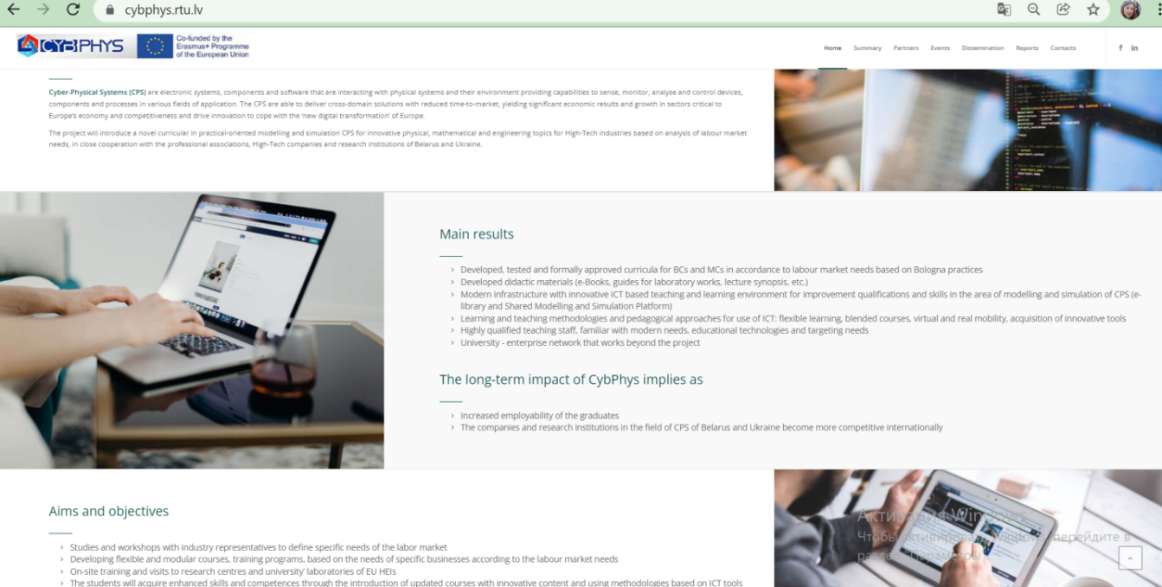

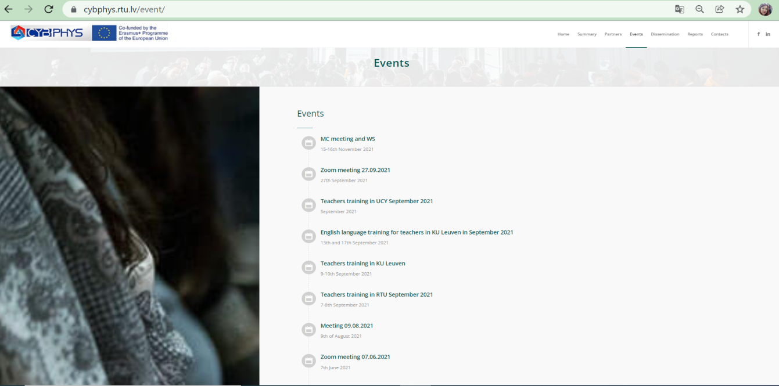

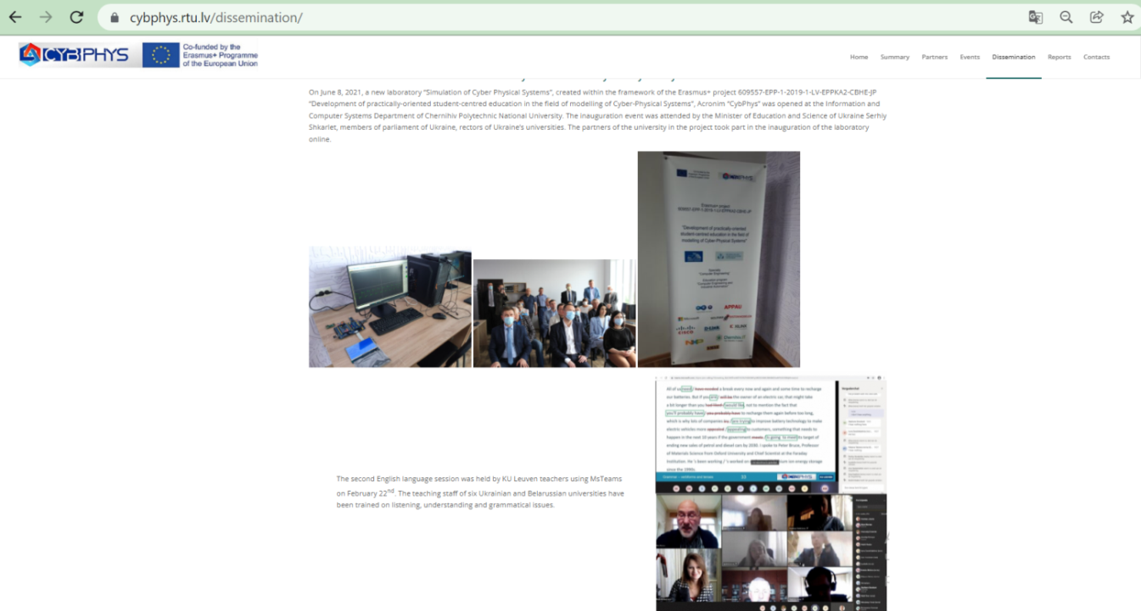

The CybPhys publicly accessible website conveys general information about the project and enables visitors to understand its goals and potential outcomes. The following elements can be found on the website:

* General information about the CybPhys project (including texts of application forms, etc.);
* News about the progress of the project, including press releases, workshops and managing meetings documents (schedules, minutes, presentations, etc.), descriptions of student training sessions, sessions and workshops for stakeholders, etc.;
* A summary of the CybPhys project;
* Important background information on the project;
* Important documentation on the project, such as a demo on the e-environment and SMSE platform used in the project;
* Partner profiles and their contribution to the project;
* Contact information

The traffic on the project’s website is monitored using widely-adopted tools, such as Google Analytics. Specifically, for the project’s website, internal tools for measuring impact will be adopted. This will create a good awareness for the consortium and help further target interested stakeholders.

The Moodle platform which is currently in use, is maintained and hosted by Belarusian State University. However, all consortium partners will have excess to the platform and will contributing to its content during the implementation of the project - e-books, curricula and study programs, project documentation (reports and minutes of managing meetings and workshops, Ex-Ante Report, other intermediate reports), etc.).

It is planned that all materials on the project will be transferred to the educational platform of the Chernihiv Polytechnic

**4.1.2. Promotional material**

**4.1.2.1. Project logo**

The design of the CybPhys logo was accepted by partners at the MC meeting 2. Following several consortium partner suggestions and an iterative selection process, the following was the winning design offered by MSPU, which will be used in all project dissemination and branding materials. The logo is also shown below at the end of this issue.



**4.1.2.2. Project leaflet**

During the first year of the project, an introductory leaflet offered by RTU was designed, aimed at promoting the project objectives, the participating consortium organizations, and the beneficiaries of the expected outcomes.

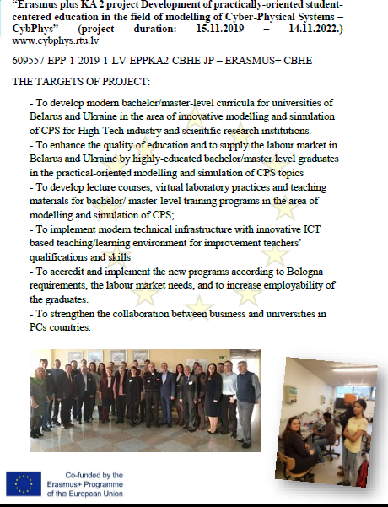

**4.1.2.3. Project posters**

Posters should be designed and displayed at the 3 participating academic institutions - National University Chernihiv Polytechnic, Kharkiv National Automobile and Highway University and Kryvyi Rih National University.

**4.1.2.4. PR campaign**

The consortium will undertake PR campaigns using a series of e-mail, Internet media and face-to-face promoting the project goals, objectives and expected outcomes. Emphasis will be put on the need to address the importance of striving to reform the Ukrainian higher education systems according to the Bologna practices.

More specifically, for the media channels, the consortium will proceed in identifying key press channels (printed, online, TV and radio) at National and EU level. CybPhys project communication is therefore oriented also to:

Facebook: <https://www.facebook.com/groups/227194018274534/?ref=share>

Linkedin: <https://www.linkedin.com/groups/12355821/>

Twitter

Instagram

Like other initiatives, the consortium of CybPhys recognizes the remarkable importance that social media plays nowadays, being a pivotal tool towards impact and reach in communication and dissemination activities. As so, the project identified social media as very relevant channels to achieve the project’s dissemination goals. Through Social media, the information about the progress of the project will be disseminated regularly and with reference to the CybPhys project website. Graphical and video information about the project´s progress and outputs are preferable.

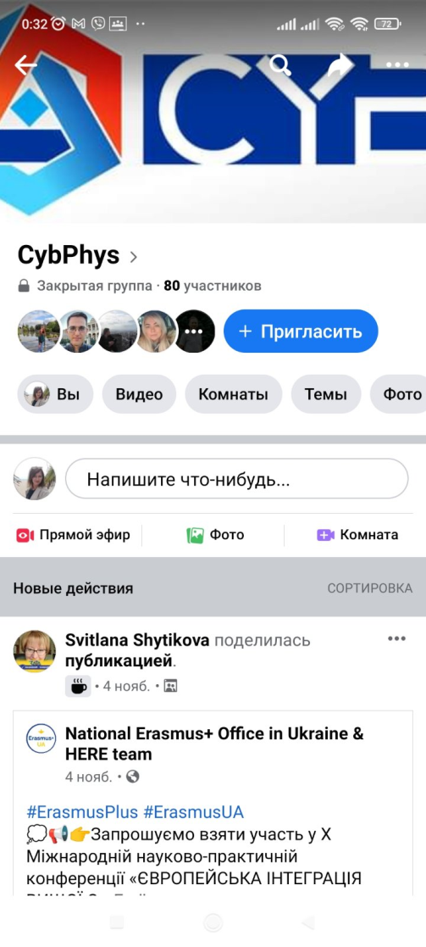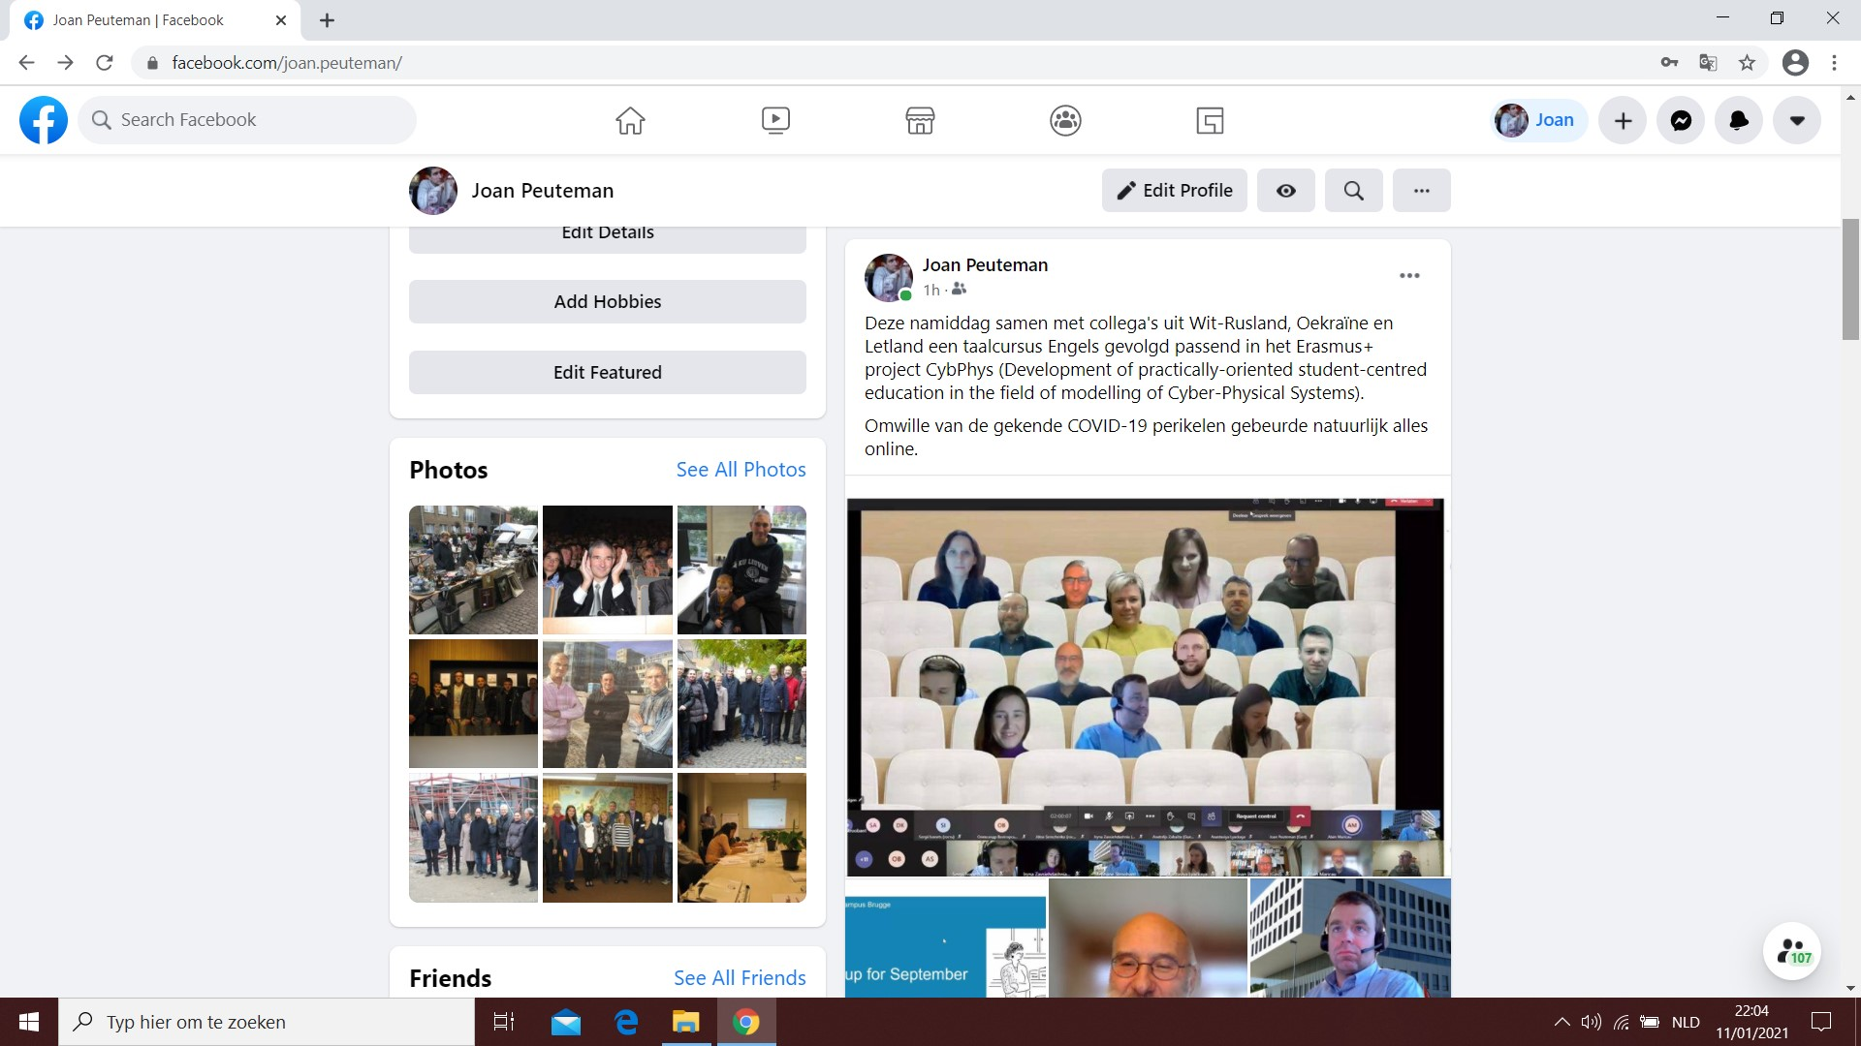

**4.2. Building understanding**

A second-level of planned activities are mainly targeting creating understanding about the content of the CybPhys project. Such activities includes the described below issues.

**4.2.1 Announcements/Presentations at workshops, seminars and conferences**

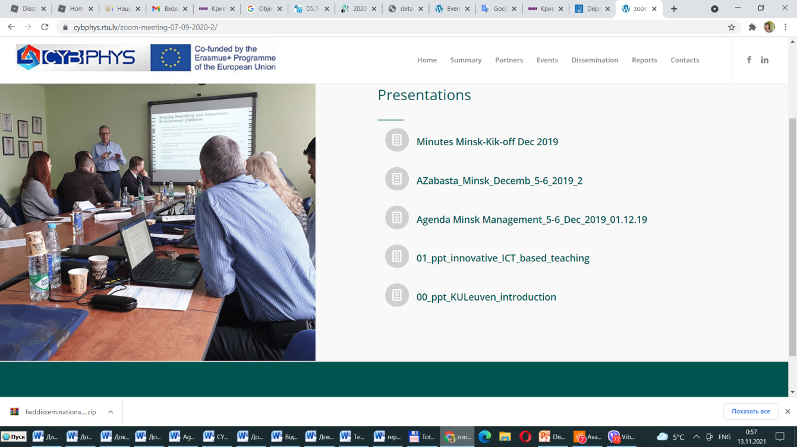Conferences, workshops and other scientific and similar events are considered as one of the most effective dissemination tools. For this reason, consortium partners have agreed to participate in carefully chosen conferences and to organize local workshops, round tables and sessions to promote the project. Consortium partners will make presentations and also present papers and posters at various conferences.

The consortium will maintain and update the list of planned and attended conferences and other events and use a series of metrics to capture the impact of these events. For example, the location of the event, the number of attendees, the type of work presented, and other related information will be captured through the metrics.

**Ongoing and planned events:**

**Ongoing and planned events:**

1. **English language course for teachers (Belgium)**

September 12, 2021 - September 18, 2021

***Location:***

At the premises of KU Leuven – Bruges Campus, Spoorwegstraat 12, 8200 Bruges, Belgium.

***Description of activity(ies)***

Participation at the English language course - Introductory session, Structuring speech, Referring to visuals, Speech delivery, Tutoring students: instructions and suggestions, Improving spoken English), Guided English tour in the old city center of Bruges, Interacting with colleagues.

***Key relevant CybPhys target groups***: tecahers of CPNU, KhNAHU and KNU.

1. **(Belgium)**
2. **(Belgium)**
3. **(Belgium)**

**4.2.2. Press releases**

As has been already mentioned, during the lifetime of the project and when important milestones have been met, the consortium will prepare dedicated press releases to be disseminated to the press and in Internet. The press releases will also be translated and disseminated in different languages.

The press releases will be devoted to the first set of results become available, such as the sessions for stakeholders and other meetings which are shifted on the later time due to Corona-virus.

**4.2.3. Communication to other projects**

The CybPhys consortium will set up communication channels and links to relevant EU and National projects.

**4.2.4. Final conference**

A final conference will be organized by Kriviy Rih National University in order to disseminate the project and its outcomes. The aim is to reach a broad and diverse audience of individuals interested in the project and the field of applied physics in general in order to promote the actions undertaken during the CybPhys project, its outcomes, and propose new paths for promoting further the modernization of education in the field of CPS modelling in Ukrainian universities.

**4.2.5. Publications**

As the CybPhys project has broader educational and research perspectives, it is expected that the partners will perform dissemination and exploitation activities aimed towards the scientific community. Therefore, the consortium plans to prepare and submit articles for publications in high quality academic conference proceedings and journals.

In addition to presentations, the publications may also be accompanied by demonstration scenarios and other visual materials promoting the project.

**5.** **Achieving Engagement**

While activities undertaken during the CybPhys project will benefit primarily the Ukrainian higher education systems, participating Universities and their students and master-level students, the actual engagement will reach a wider audience in Ukrainian society and the EU community. A reformation/improvement of the Ukrainian higher education systems to adhere to the Bologna practices and the involvement of the industry, the educational institutions and the Ukrainian Ministrys of Education and Science in this process will not only build awareness about the project but will also guide students of different levels in developing the required competences, skill and knowledge to compete in a globally competitive labor market. For this reason, the identified groups of interested stakeholders will be students of different levels, universities and faculties, and other educational and industrial experts that will be involved into discussions concerning the project’s goals, objectives and outcomes. Engagement will also be achieved by arranging face-to-face meetings with interested stakeholders, discussing and receiving feedback from them, introducing the newly developed and modernized bachelor- and master-level programs in the field of CPS modeling, and updating courses and teaching materials/tools in the declared field. The engagement of project stakeholders will also be required to administer surveys, questionnaires, and field visits to other Ukrainian higher education institutions and enterprises.

To involve the labor market, consortium partners will undertake the following steps:

* + devise two sets of questionnaires: a curriculum questionnaire and a questionnaire for the evaluation of special courses and laboratory study programs.
  + then a panel of experts who are also members of the Ukrainian consortiums will be interviewed. For example, experts from MetinvestHolding, ArselorMittal Kryvyi Rih, V.M. Glushkov Institute of Cybernetics of National Academy of Ukraine as well as the heads of the departments/laboratories of Belarusian and Ukrainian universities will be interviewed. The experts will be invited to share their views on the improvement of higher education systems in Ukraine and the importance of introducing new training programs, new/improved courses and laboratory works from CPS modeling field to help students build new competences and skill in this area. Consequently, the results of the project will engage further collaboration between HEIs, NGOs as well science and business in Ukraine and promote the availability of a high-skilled workforce in the domain of CPS modeling and simulation.

**5.1. Maximize impact and sustainability**

The last but not least by influence on the dissemination and exploitation activities is the maximisation of the impact and sustainability of project results. They are important to clearly identify all exploitable results and outcomes, such as the development of modern bachelor- and master-level programs in the field of CPS modelling, the development/modernization of courses and teaching materials/tools and ICT-based teaching/learning activities, the preparation of students of different levels to compete in the labor market. Through this process, the reformation/improvement of the education institutions in Ukraine and the implications of this process for the Ukrainian educational systems as a whole will be addressed to achieve a higher level of impact and sustainability for the project.

New curricula on CPS modelling will also be developed. These programs will be approved by educational government bodies of Ukraine and Universities` authorities during the third year of the project. In the second year of the project, study programs, as well as sets of curricula subjects (special courses and laboratory practices) for each of the universities will be developed on the basis of the approved model (standard) educational programs.

All these actions and initiatives will be promoted to maximize the impact and sustainability of the project. Compatible standard study programmes (including lecture courses, laboratory classes and appropriated didactic materials and tools) will be developed in English and Ukrainian. The teaching/learning materials described in study programs of courses and laboratory practices will be distributed by 9 e-books. The overall objective of the exploitation strategy of the project will be that the consortium partners (the participating academic institutions) collaboratively exploit the results and outcomes and reach out to both the education and industrial sectors to ensure high impact and visibility of the project results.

**6. Description of Partner Involvement in Dissemination and Exploitation Activities**

Consortium partners have a rich and diverse experience in delivering EU projects and in building the effective dissemination and exploitation networks in order to reach the declared goals, objectives and outcomes be the interested education, industry and other related stakeholders. Consortium of all 9 partners will be involved in the multiple dissemination and exploitation activities that will be undertaken throughout the duration of the project and beyond. Kryvyi Rih National University will lead consortium partners in ensuring that all dissemination and exploitation activities are delivered on time and have a high impact within the Ukraine and broader EU community. Some of the activities that consortium partners will undertake include:

* Press conferences, press releases, leaflets, posters, information in TV, radio and social media, as well as project logo
* Project website design/development and its regular updating by information on dissemination and a course of the project implementation
* Seminars/workshops for stakeholders
* Information sessions
* Final conference
* Double-sided agreements
* Preparation for 2nd year bachelor- and master-level programs testing beyond the project
* Conference papers and presentations

Table 1 below provides a detailed plan of all dissemination and exploitation activities with each partner’s involvement, responsibility and due dates as they appeared on the original proposal that was funded. The status of each dissemination activity is also indicated. This plan is leaned on the dissemination and exploitation goals described in WP6.

**Table 1. Plan of dissemination and exploitation activities**

|  |  |  |  |  |
| --- | --- | --- | --- | --- |
| ***Item*** | ***Activity*** | ***Responsibility*** | ***Due Date*** | ***Status*** |
| *WP6.1* | *Information/ promotional materials* | *KNU* | *14.11.2022* | *Permanently* |
| *M01 (WP6.1)* | *Press Conferences* | *All Consortium Partners (RTU, KU Leuven, UCY, CNTU, KhNAHU, KNU, Ukrainian ass. Partners)* | *14.11.2022* | *In progress* |
| *M01 (WP6.1)* | *Press Releases* | *All Consortium Partners (RTU, KU Leuven, UCY, BSU, GSU, MSPU, BPS, RANI, INTEGRAL, CNTU, KhNAHU, KNU, Ukrainian ass. Partners)* | *14.11.2022* | *In progress* |
| *M01 (WP6.1)* | *Leaflets* | *Riga Technical University (RTU)*  *All Consortium Universities (RTU, KU Leuven, UCY, CNTU, KhNAHU, KNU)* | *14.11.2022* | *Ready*  *In process* |
| *M01 (WP6.1)* | *Posters* | *All Consortium Universities (RTU, KU Leuven, UCY, CNTU, KhNAHU, KNU)* | *14.11.2022* | *KU Leuven – ready*  *Others – in process* |
| *M01 (WP6.1)* | *TV and Radio Interviews* | *All Consortium Partners* | *14.11.2022* | *In progress* |
| *M01(WP6.1)* | *Social Media* | *University of Cyprus (All Partners)* | *14.11.2022* | *Permanently* |
| *M01 (WP6.1)* | *Project Logo* | *Riga Technical University (RTU)* | *14.11.2022* | *Ready* |
| *M01 (WP6.1)* | *Conference Papers and Presentations* | *All Consortium Partners* | *14.11.2022* | *In progress* |
| *WP6.2* | *Information sessions for target groups* | *All Consortium Partners* | *14.11.2021* | *Permanently* |
| *M02 (WP6.2)* | *Round table of representatives of job markets of Ukraine* | *CNTU, KhNAHU, KNU* | *14.11.2021* | *In progress* |
| *M02 (WP6.2)* | *Final Conference* | *KNU* | *14.11.2022* |  |
| *M03 (WP6.3)* | *Use of project Web Portal, Moodle platform and social media* | *Riga Technical University (RTU)*  *CPNU* | *14.11.2022* | *Permanently* |
| *M04 (WP6.4)* | *Recommendations for new training programs for the targeted stakeholders beyond the project* | *All Consortium Universities and associated partners from Ukraine* | *14.11.2022* | *Ready* |
| *M04 (WP6.4)* | *Preparation of bachelor- and master-level programs* | *All Consortium Universities from Ukraine* | *14.11.2022* | *Ready* |
| *M04 (WP6.4)* | *Reviewing of bachelor- and master-level programs* | *All Consortium Universities from Ukraine)* | *14.11.2022* | *In progress* |
| *M04 (WP6.4)* | *Testing of bachelor- and master-level programs* | *All Consortium Universities from Ukraine* | *14.11.2022* | *In progress* |
| *M05 (WP6.5)* | *Strengthening the academia – industry network* | *All Consortium Universities from Ukraine and associated partners* | *14.10.2021* | *In progress* |
| *M05 (WP6.5)* | *Сonducting surveys among members of the academia – industry network concerning needs of job markets* | *All Consortium Universities from Ukraine* | *14.11.2022* | *One survey – all partners*  [*https://eduphys.bsu.by/mod/folder/view.php?id=2253*](https://eduphys.bsu.by/mod/folder/view.php?id=2253) |
| *M05 (WP6.5)* | *Double-sided Agreements between Partners and NGO from Ukraine* | *All Consortium Universities and associated partners from Ukraine* | *14.11.2022* | *In progress* |
| *M06 (WP6.6)* | *Hosting and maintenance of e-Learning and SMSE platform beyond the project* | *CPNU* | *14.11.2022* | *Permanemnly* |
| *M06 (WP6.6)* | *Development new virtual laboratory works on CPS modeling* | *CPNU* | *14.11.2022* | *In progress* |
| *M07 (WP6.7)* | *Strengthening*  *cooperation beyond the project to sustain the outcomes/results* | *All Consortium Universities from Ukraine and associated partners* | *14.11.2022* | *In progress* |

The course of the CybPhys implementation will be controlled through Communication Reports in form of presented in **Attachment 1**, which will be sent once every three months by every partner university to INP BSU.

**7. Metrics and KPI**

For all activities involving dissemination and communication, it is important to have tools to access the reach, success and status of each initiative. For these reasons, quantitative metrics should be used, so that the success of the initiative can be measured and, if necessary, adapted towards achieving project goals.

Table 2 summarizes the KPI to be used in each dissemination channel, as well as their quantitative targets throughout the project.

**Table 2. KPI and targets for each of the channels used for dissemination.**

|  |  |  |  |
| --- | --- | --- | --- |
| **Channel** | **KPI** | **Year 1 target** | **Year 2 target** |
| Website | Number of visitors |  |  |
| Social media | Number of posts |  |  |
| Number of followers/subscribers |  |  |
| Press releases | Number of press releases |  |  |
| Scientific publications | Number of journal papers/conference papers |  |  |
| Workshops/Seminars | Number of workshops/seminars organized |  |  |
| Events with other EU projects | Number of events co-organized with other EU projects or with the participation of CybPhyS partners |  |  |

**8. Conclusion**

Active and well-planned dissemination and exploitation of the project contributes to the enrichment of global knowledge in the identified target domain, to raise awareness in the scientific community and to exploit potential synergies with related research projects. This document summarises the current and planned state of dissemination and exploitation activities carried out as part of the CybPhys project. The CybPhys consortium has been active in all dissemination channels: conferences, meetings, workshops, and publications. Furthermore, a considerable repository of dissemination material, including press releases, posters and leaflets, was created and distributed.

The Internet presence of the project ranges from the CybPhys project’s main website, which comprises a public means of communication and providing information to interested stakeholders, as well as to the Facebook and LinkedIn groups.

**Attachment 1**: Table 3. The form of the **report on dissemination and communication activities** in CybPhys.

*This table shows examples of dissemination activities undertaken by the project partners****\*)****.*

|  |  |  |  |  |
| --- | --- | --- | --- | --- |
| **Date** | **Partner,**  **Presenter, Author** | **Title of document or activity** | **Type (doc, ppt, etc)** | **Link to document on slideshare, blogspot, website, etc** |
| 07/09/19  09/12/19  12/03/20  03/08/20  07/09/20  05/10/20  29/10/20  30/10/20  10/11/20  15/12/20  18/01/21  03/02/21  09/02/21  25/02/21  11/03/21  21/03/21 | KNU,  Mykola Stupnik,  Liydmila Kruhlenko,  Natalia Morkun,  Iryna Zavsiehdashnia | News about CybPhys events (zoom meetings, Pyton workshops, English language workshops) on FB pages of  - KNU; International Relations Department of KNU;  Automation, Computer Science and Technologies Department KNU |  | <https://www.facebook.com/knu.edu.ua>  <https://www.facebook.com/groups/1414976482086783>  <https://www.facebook.com/aknt.knu> |
| Since Dec 2019 | KNU  Liydmila Kruhlenko | Current information about Erasmus  + projects on KNU Dept of International Relationships |  | <http://doir.knu.edu.ua/%d0%bf%d1%80%d0%be%d0%b5%d0%ba%d1%82%d0%b8/> |
| 07/09/20  05/10/20  29/10/20  30/10/20  10/11/20  15/12/20  18/01/21  03/02/21  09/02/21  25/02/21  11/03/21  21/03/21 | KNU  Natalia Morkun,  Iryna Zavsiehdashnia | Topical news  about CybPhys  in thematic FB group  «Automation and computer sciences» |  | <https://www.facebook.com/groups/aknt.knu> |
| Since 04/01/2020 | KNU,  Natalia Morkun,  Vitalii Tron  Iryna Zavsiehdashnia | Information about CybPhys project and new curricula on the site of Automation, Computer Science and Technologies Dpt, KNU |  | http://aknt.knu.edu.ua/erasmus-cybphys/ |
| Since January 2020 | KNU  Yurii Monastyrskyi  Volodymyr Sistuk | Information about CybPhys project and new curricula on the site of Transport Technologies Dpt, KNU |  | https://at.knu.edu.ua/%D0%B5%D1%80%D0%B0%D0%B7%D0%BC%D1%83%D1%81-erasmus |
| January 2021 | KNU  Liydmila Kruhlenko | Together with European and Belorussian partners the scientific paper “Approach for Cross-Domain Study Curricula in Cyber-Physical Systems for Belarusian and Ukrainian Universities” was published in the frame of RTUCON2020 international conference. |  | https://www.researchgate.net/publication/348620576_Approach_for_Cross-Domain_Study_Curricula_in_Cyber-Physical_Systems_for_Belarusian_and_Ukrainian_Universities |
| October 2020 | KNU  Natalia Morkun,  Iryna Zavsiehdashnia  Vitalii Tron,  Serhii Ruban | International Conference on Science, Engineering & Technological Innovation ( 24 - 25   October, 2020 )  Report on the topic «International grant activity: Erasmus+ Modelling CybPhys 609557» |  | https://researchculturesociety.org/icseti-oct-2020/ |
| 16/02/21 | KNU  Natalia Morkun | On February 16, 2021, during the presentation of the KNU Erasmus + (KA2) UTTERLY project team, information about the CybPhys project, its goals, results, implementation experience was also provided |  | <https://www.instagram.com/p/CLZ4Ox3p6w9/?igshid=8af4o6ap4bt1>  <https://www.facebook.com/aknt.knu>  <https://www.facebook.com/knu.edu.ua> |
| 18/01/21  03/02/21  09/02/21  25/02/21  11/03/21  21/03/21  29/09/21 | KNU  Natalia Morkun  Iryna Zavsiehdashnia  Vitalii Tron | The official news Telegram channel of the Faculty of Information Technologies of KNU |  | https://t.me/fitknu |
| October  December 2020 | KNU  Natalia Morkun | In October and December 2020, Kryvyi Rih National University was accredited by the National Agency for Quality Assurance in Higher Education of the specialties 122-Computer Science and 151- Automation and Computer-Integrated Technologies.  The report mentions the #CybPhys project many times. In the process of passing accreditation, experts (representatives of Lviv Polytechnic, Central Ukrainian National University, Khmelnytsky National University, National Metallurgical Academy, Vinnytsia National Technical University) were familiarized with CybPhys project and project documentation, were told about the experience of the project. Reports were published on the KNU website | | https://cutt.ly/qYBiRVX  https://cutt.ly/sYBiLyl |

***\*)*** *Every member of CybPhys consortium should send such report once in every 3 months to Lyudmila Kruhlenko by address* [*kruhlenko@knu.edu.ua*](mailto:fedotov@bsu.by)