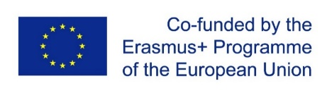

Project Management Meeting and Workshop on the ERASMUS+ Project CybPhys at the KIOS Research and Innovation Center

Between September 19th and 21st of 2022, a Project Management Meeting and a workshop on the development and modernization of curricula in the field of Cyber-Physical Systems (CPS) was held at the KIOS Research and Innovation Center. Consortium members paid particular attention to the overall project progress; the reform and modernization of curricula in Cyber-Physical Systems in Ukrainian Higher Education Institutions (HEIs); the development and deployment of a Sharing Modelling and Simulation Platform to facilitate virtual learning and virtual laboratory work in the field; and the introduction of new methodologies for implementing distance and virtual laboratory work.
The KIOS Research and Innovation Center of Excellence contributes to the project by leading all activities related to Quality Assurance and by offering two short training events, one for academic faculty and one for Ukrainian students in the three participating Ukrainian Higher Education Institutions.
The first training event was held back in September of 2021, and it focused on novel educational and research tools for critical infrastructure modelling, monitoring and control, as well as on demonstrations on smart cities, intelligent water network monitoring and control, intelligent transportation and smart grids, using the KIOS CoE testbed facilities.
The second training school will be designed for the needs of Ukrainian students in the field, offering them a chance to explore and experiment, under KIOS CoE researchers’ supervision, with this type of infrastructure.

