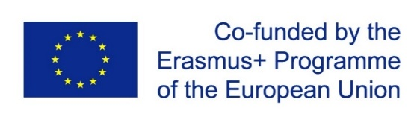

Erasmus+ project CybPhys:
“Development of practically-oriented student-centred education in the field of modelling of Cyber-Physical Systems”
Location:
At the premises of KU Leuven – Bruges Campus, Spoorwegstraat 12, 8200 Bruges, Belgium
Practical information:
If you have questions, send an e-mail to Joan Peuteman (joan.peuteman@kuleuven.be).
Invitation letter:
If you need an invitation letter, please send an email to Joan Peuteman (joan.peuteman@kuleuven.be) (if necessary with the suggested text but we also have a template available). We will take care of that invitation letter with stamps of KU Leuven.
Place of venue:
KU Leuven Bruges Campus: Spoorwegstraat 12, 8200 Bruges (Belgium). The campus is located very close to the railway station of Bruges. You can see the campus from a number of platforms of the railway station.
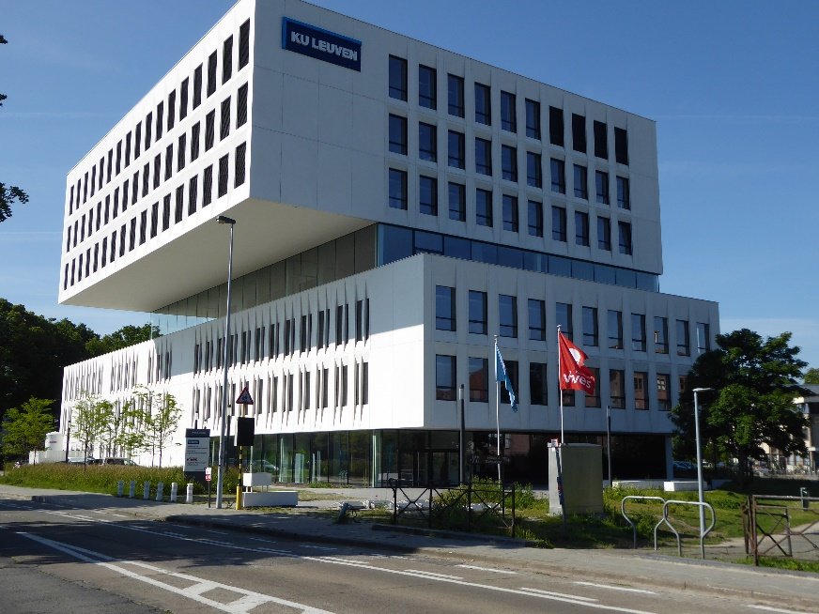

A detailed map with the location of the campus nearby the railway station of Bruges.
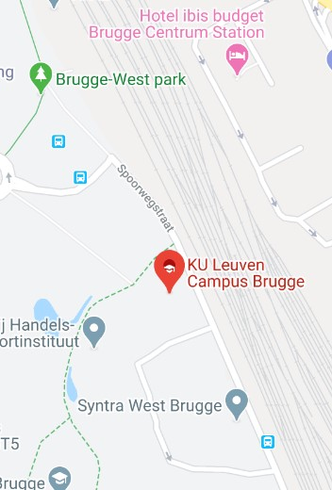

Global map of the old city center of Bruges with an indication of the location of the KU Leuven Bruges Campus.
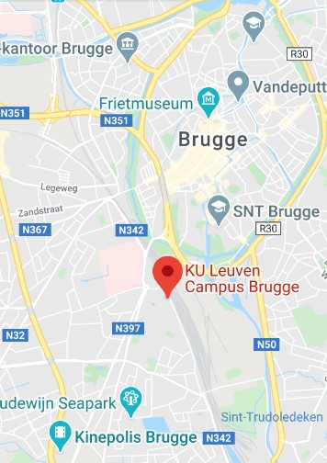

Arrival:
Although access is possible from airports outside Belgium, two airports in Belgium are important:
- Brussels Airport (Zaventem):
- Having arrived at the airport, you can go to the railway station nearby the airport. You can take several trains to Bruges (tickets can be bought in the railway station itself). All trains going to “Knokke-Blankenberge” and “Oostende” also stop in Bruges (Brugge). IC Intercity Trains are sufficiently fast.
- Information about the trains can be found on the railway company website NMBS. On that website you can find information of the trains with departure from “Zaventem, Luchthaven Brussel Nationaal” to “Brugge”.

- Brussels South Charleroi Airport (Charleroi which is actually another city than Brussels):
- Having arrived at the airport, possibly the most easy way to travel to Bruges is taking a FLIBCO dedicated bus. On that website you can find information of the buses going from the airport to Brugge. The bus stops in Bruges very close to the railway station and the KU Leuven Campus. Select bus from “Charleroi Airport (CRL)” to “Brugge”.
There are other means to arrive in Bruges but the two possibilities discussed here are comfortable.

Accommodation:
Bruges is a medieval city attracting a lot of tourists every year. This implies Bruges has a lot of hotels spread among the city. In general, hotels in Bruges are not cheap.
We recommend the following 3 hotels in Bruges which are close to the KU Leuven campus.
- IBIS Budget Brugge Centrum Station (very nearby the KU Leuven Campus)

- Hotel Novotel Brugge Centrum: (15 minutes’ walk to the KU Leuven Campus)

- Crowne Plaza Brugge: (located in the old city center close to the city hall)
Hotels can be booked a.o. at Booking.com.
Quite close to the campus, there is also a youth hostel: https://www.jeugdherbergen.be/en/bruges with address “Baron Ruzettelaan 143, 8310 Brugge” and email brugge@vjh.be . It will be cheaper but it is a youth hostel, not a real hotel.
Car parking:
When participants want to arrive in Bruges by car, they are able to use the private car park of the KU Leuven Campus (for free). They need a numerical code to enter the car park. Ask the numerical code to Joan Peuteman (joan.peuteman@kuleuven.be) since the code changes with respect to time.

